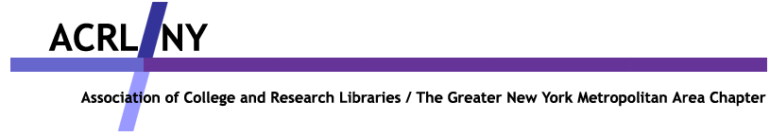
LONG ISLAND SECTION
Along with
HOFSTRA UNIVERSITY LIBRARIES
NCLA – ACADEMIC AND SPECIAL LIBRARIES DIVISION &
LILRC – RESOURCE SHARING COMMITTEE

Present

CREATING SURVEYS, AND MAKING SENSE OF STATISTICS:
A HANDS ON WORKSHOP FOR LIBRARIANS
Includes an afternoon training session using SPSS.

SPEAKER: DR. MARC SILVER, Full Professor and Chair of Sociology Department, Hofstra University

DATE: September 23, 2005
Hofstra University, Axinn Library Room 108
8:30 a.m. – 4:00 p.m. (8:30 a.m. - 9:00 a.m. Registration & Breakfast)
Fee: $15.00 for members only of ACRL/NY, NCLA-ASLD, and LILRC

FIRST COME FIRST SERVED – space limited to 40 people only
See verso for full description and speaker biography
See ACRL/NY website for more details at www.acrlny.org
See Hofstra University website for directions at www.hofstra.edu/StudentServ/IC/ic_directions_maps.cfm

Registration Deadline is September 13, 2005.
REGISTRATION FORM for Creating Surveys & Making Sense of Statistics
September 23, 2005, 8:30 a.m. – 4:00 p.m., Hofstra University Axinn Library Room 108

Name: __________________________________ Phone: ________________________

Library: _________________________________ Fax : ________________________

I am a member of :  ACRL/NY  NCLA – ASLD  LILRC
My check for $15.00 payable to ACRL/NY is enclosed.
Boxed Lunch Choice:  Ham  Roast Beef  Turkey  Vegetarian

Send form and payment to Eloise Bellard, at Adelphi University Swirbul Library Reference Dept., South Avenue, Garden City, New York 11530.
For further information contact:
Eloise Bellard, Chair ACRL/NY Long Island Section (516) 877-3584 or e-mail bellard@adelphi.edu
Sandhya Srivastava, Vice Chair ACRL/NY long Island Section (516) 463-5959 or e-mail librsds@hofstra.edu .

This program is for librarians in academic libraries who are interested in learning about empirical research and SPSS techniques in order to do research for publication.

Description: This training session will explore discrete statistics, correlation, hypothesis testing, and survey construction on quantitative techniques in the morning session. The afternoon session will be specifically geared to training in SPSS and use of a specific data set to enhance and reinforce understanding of the software.

Objectives:

At the end of the workshop, participants will:

 Be able to understand quantitative techniques in statistics.

 Create their own survey tool using techniques and advice learned.

 Learn SPSS and be able to use tool for their own data set.

 Understand and reinforce knowledge learned by using it for their own research
needs.

Speaker:
Dr. Marc L. Silver received his degree from Columbia University in 1981. He first joined the faculty of Hofstra University in 1982. Between 1994 and 2000 he served as Chairperson of the Department of Sociology & Anthropology. He has been Chair of the Department of Sociology since 2003. His research interests have been in the areas of organizations, work relations and the labor process, housing policy, and racial segregation in the suburbs.
Dr. Silver teaches courses in statistics, research methodology, social theory, race relations, and the sociology of work. Both his teaching and research have been influenced by his concern for social justice and interest in the processes of social change. His principal focus as a teacher has been to help his students develop the intellectual and communicative skills that will enable them to think critically about social issues, to be able to look beyond the "taken for granted" aspects of social life, and to dare the ruthless criticism of everything existing.
Silver is also a winner of the Lawrence A. Stessin Prize for Outstanding Scholarly Achievement, and he serves as the Center of Teaching & Scholarly Excellence’s Program Evaluator and Assessment Consultant. In the Spring 2005 semester, Silver presented a four- part Empirical Research Workshop Series for faculty inexperienced with empirical research.

